BRACT’s
Vishwakarma Institute of Technology, Pune
Practical Implementation Sheet
Department: CSE-AI Semester: 5 Academic Year: 2026-27
Division: E Batch: 1 Practical No: 10
Roll no:31 PRN No: 12414893 Name of Student: Kartiki Rasane
Subject Name : Deep Learning

Problem Statement : Design and implement a deep learning application for audio classification that incorporates Speech-to-Text (STT) and Text-to-Speech (TTS) using an appropriate deep learning architecture, and evaluate its performance using suitable metrics.
Algorithm :
- Load the audio dataset and select the required speech commands.
- Extract Mel spectrogram features from audio recordings.
- Split the dataset into training and testing sets.
- Build and train a CNN model for audio classification.
- Evaluate the model using accuracy, precision, recall, and F1-score.
- Use Whisper to convert speech into text (STT).
- Use gTTS to convert the recognized text into speech (TTS).
- Display the predicted class and play the generated audio..

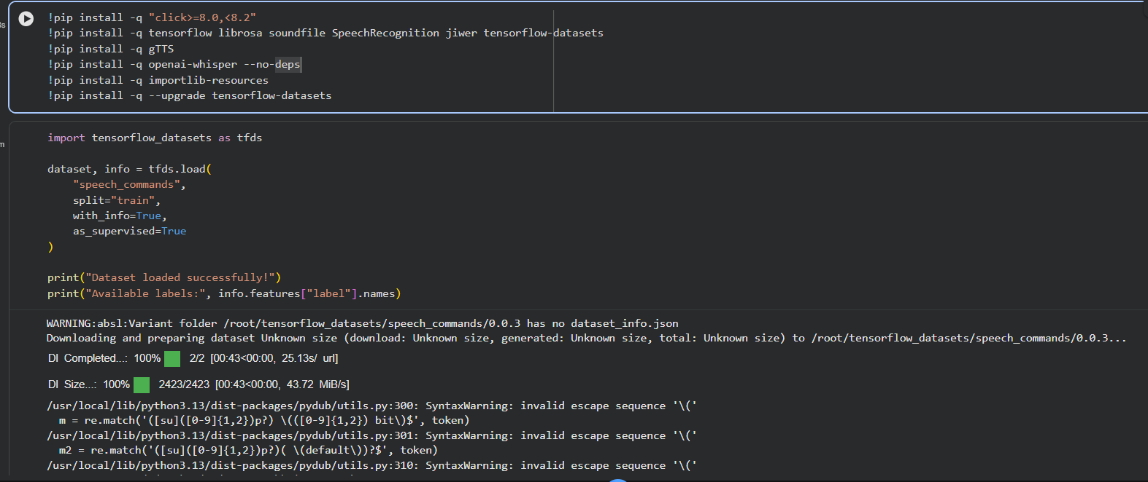
Code/ Output:
